Photo News: JP Morgan Chase Delegation Visits FRC

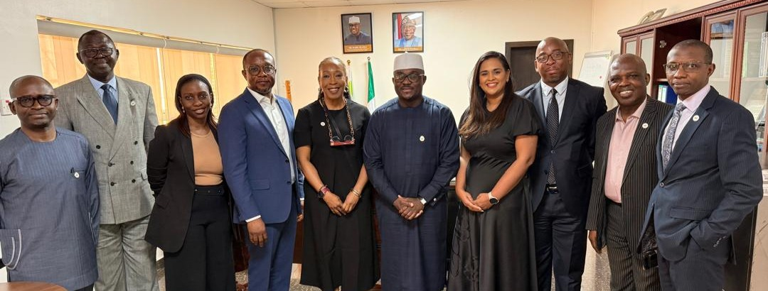
A delegation from the JP Morgan Chase Representative Office (Nigeria) Limited, led by its Managing Director, Mr. Olagunju Adedapo Adedayo, visited the Lagos office of the FRC on Tuesday, March 11, 2025. The visit aimed to provide insight into JP Morgan Chase Representative Office (Nigeria) Ltd.’s structure, nature and scope of operations in Nigeria.

The delegation included key members such as Ronelle Reddy, Chief Finance Officer; Thulani Dlamini, V. P. Compliance; and Uyinmwen Iyamu, Senior Associate. They were warmly received by the Executive Secretary/CEO of FRC, Dr. Rabiu Olowo, along with other senior management members of the Council.

Photo News: ARAACM Delegation Visits FRC to Foster Collaboration

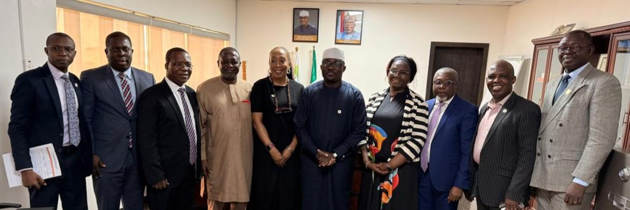

The Association of Reporting Accountants and Auditors in the Capital Market (ARAACM) paid a courtesy visit to the Financial Reporting Council (FRC) of Nigeria on Tuesday, March 11, 2025, at the FRC's Lagos office. The purpose of the visit was to discuss collaborative efforts aimed at ensuring compliance with the FRC Act, regulations, codes, and guidelines.

The delegation was warmly received by the Executive Secretary/CEO of the FRC, Dr. Rabiu Olowo, along with some senior management members of the Council.

