ICSAN Confers Honorary Fellowship on FRC Boss, Dr. Rabiu Olowo

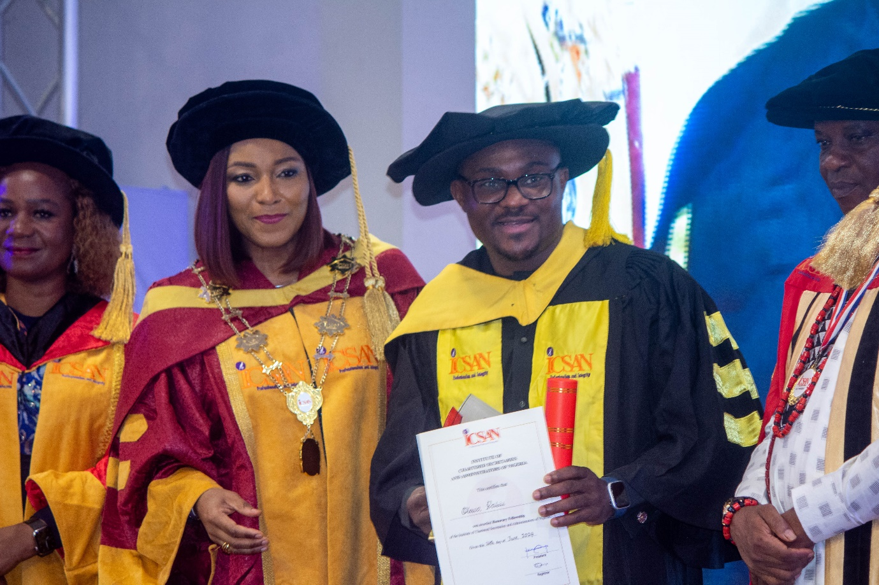

The Institute of Chartered Secretaries and Administrators of Nigeria (ICSAN) has honored Dr. Rabiu Olowo, Executive Secretary/Chief Executive Officer of the Financial Reporting Council of Nigeria (FRC), with an Honorary Fellowship Award. The award was presented by ICSAN President/Chairman of Council, Mrs. Funmi Ekundayo, FCIS, at the ICSAN 2024 Annual Dinner/Awards held yesterday at the MTN Plaza, Ikoyi, Lagos.

According to Mrs. Ekundayo, the award recognizes Dr. Olowo's exceptional leadership, entrepreneurial, and administrative skills, as well as his commitment to promoting good governance in Nigeria. Dr. Olowo expressed gratitude for the recognition, acknowledging it as a personal challenge to continue serving the Council and the nation diligently.

